**Photo Editing & Organization**

**Page 1 – Your Application Topic**

**Describe your topic and the top PC components for your topic.**

**Photo Editing & Organization**

They are in charge of coordinating **photo** assignments by selecting, **editing**, and positioning photos, and publishing images in print publications and on the web.

***Include the following on this page:***

**Describe your application topic and how a PC is used?**

A photo editor works with designers and other editors to create a full, rich experience for the reader or customer.

Firstly you have to open the editing software of your choice like you can use adobe photoshop app.

Then you basically open the photo which you want to edit, and it has to be in the computer to edit it. When it's in the computer then you can basically go to the folder where you have saved your picture and bring it to the app, to start editing it. Then you pick a tool and begin editing the picture. But mostly the tools you will find would be cropping and color changes in the picture.

**· In general terms, describe what the best PC for this application would look like (e.g. speed vs portability)**

**Speed;** is **the overall speed of a computer which depends on the performance of its individual components, chiefly the processor, memory and video card.**

**Portability; It is the ability of software to be transferred from one machine or system to another.**

* **I think in general terms speed would be the best component in the pc because of that the processor, memory and video card can show their performance.**

**· Describe in more detail the top three most important PC components and explain why they are**

**important for your application.**

***The CPU***

* It is the **brain** of our computer, it is like a little chip that does all the heavy work for every application we use.
* It is also the most expensive component in the machine

***Ram***

* The CPU is the brain of the computer, but however the ram is the short-term memory.
* It is important because while your working on something, it will be saved by itself by ramm storage.
* It’s much faster than the storage space on hard drives or even SSDs, so it allows you to make changes very quickly.

***Storage***

* *A final, and often overlooked aspect of Photoshop performance is your computer’s storage.*
* There are two basic kinds of storage, classic spinning hard drives and SSDs (Solid State Drives). Hard drives are very inexpensive and give you oodles of storage, but SSDs are much, much faster. This speed will be welcome whenever you’re opening files, saving files, or booting up Photoshop.

<https://www.slrlounge.com/best-computer-specs-photoshop-computer-par/>

**Page 2 – Would-Be-Nice Features**

Describe your decisions about what PC components are less important but would be nice to upgrade if you had the money.

* Operating System [OS]
* Input Devices, Mouse
* Case

Include the following on this page:

· Describe the would-be-nice components (just below your top 3 priorities) and what your options for upgrading them would be.

* i7 processor
* Terabytes
* Ram

**· Describe the components / features at the bottom of your priority list and why you would not spend extra money on them.**

**Case** because you would not really need the case because, when you have everything you need on thee motherboard.

Input Devices, Mouse you don't really need them too because you can just have the basic accessoire that you get with the pc and use it, because it would not affect your photo editing or anything else.

**· Provide some details about different vendors / suppliers and the options they offer.**

* It is a person or company which offers someone something for sale, especially a trader in the street.
* Suppliers are basically the ones who supply down stuff for different accessories such as Pc, phones and other electronic stuff.

**Page 3 – Your Budget Machine**

Your budget is $800. Select a pre-packaged PC or customize / build a PC from parts to fit under this budget.

**Apple Mac mini 2018**

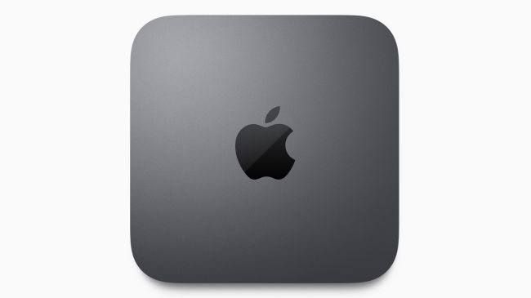

* Same small design.
* Four USB-C Thunderbolt 3 ports
* Integrated graphics aren’t all that

Include the following on this page:

·

**Your PC specs, model, cost, vendor, etc.**

* 4-Core. 3.6GHz quad-core Intel Core i3. 6MB shared L3 cache. Configurable to: 6-Core. 3.2GHz 6-core Intel Core i7. Turbo Boost up to 4.6GHz. 12MB shared L3 cache.
* Model: It was Introduced in October 2018, and it is the fourth generation product.
* Price: $750.15

·  **Priority components that you were able to include for this price.**

* Quad-core i3 processor
* 8 GB of RAM
* 128 GB of solid-state storage.

**· Priority components that you had to leave out because of budget limitations.**

* The Mac Mini starts at $800, but if you buy every single upgrade option available, it can cost you as much as $4,200. And these are the things I would have to leave because of my budget.
* It will increase the Ram storage, if you upgrade it.
* It comes with a 6-core i7 processor.
* 2 terabytes of solid-state storage.

**Page 4 – Your Budget Machine**

**Your budget is $2000. Select a pre-packaged PC or customize / build a PC from parts to fit under this budget.**

# Intel Core i5-9400 Desktop Processor 6 Cores up to 4.1 GHz

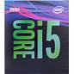**$257.99**

# Asus Prime H310M-A R2.0/CSM Desktop Motherboard

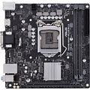**$102.11**

# Axiom 32GB DDR4 SDRAM Memory Module

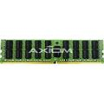**$309.99**

# 

# 

# 

# M.2 PCIe NVMe Drive for primary storage

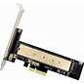**$15.99**

Seagate HDD 6 TB

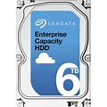**$346.18**

Visiontek Radeon HD 4350 Graphics Card

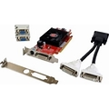**$103.51**

## 

## 1200W Computer Power Supply Module PC PSU 24Pin SATA 6Pin 4Pin Quiet LED Fan 80 Plus

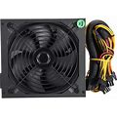**$94.15**

# Dell UltraSharp 25 PremierColor Monitor : UP2516D

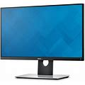**$517.99**

Case

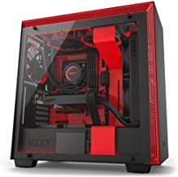**$192.77**